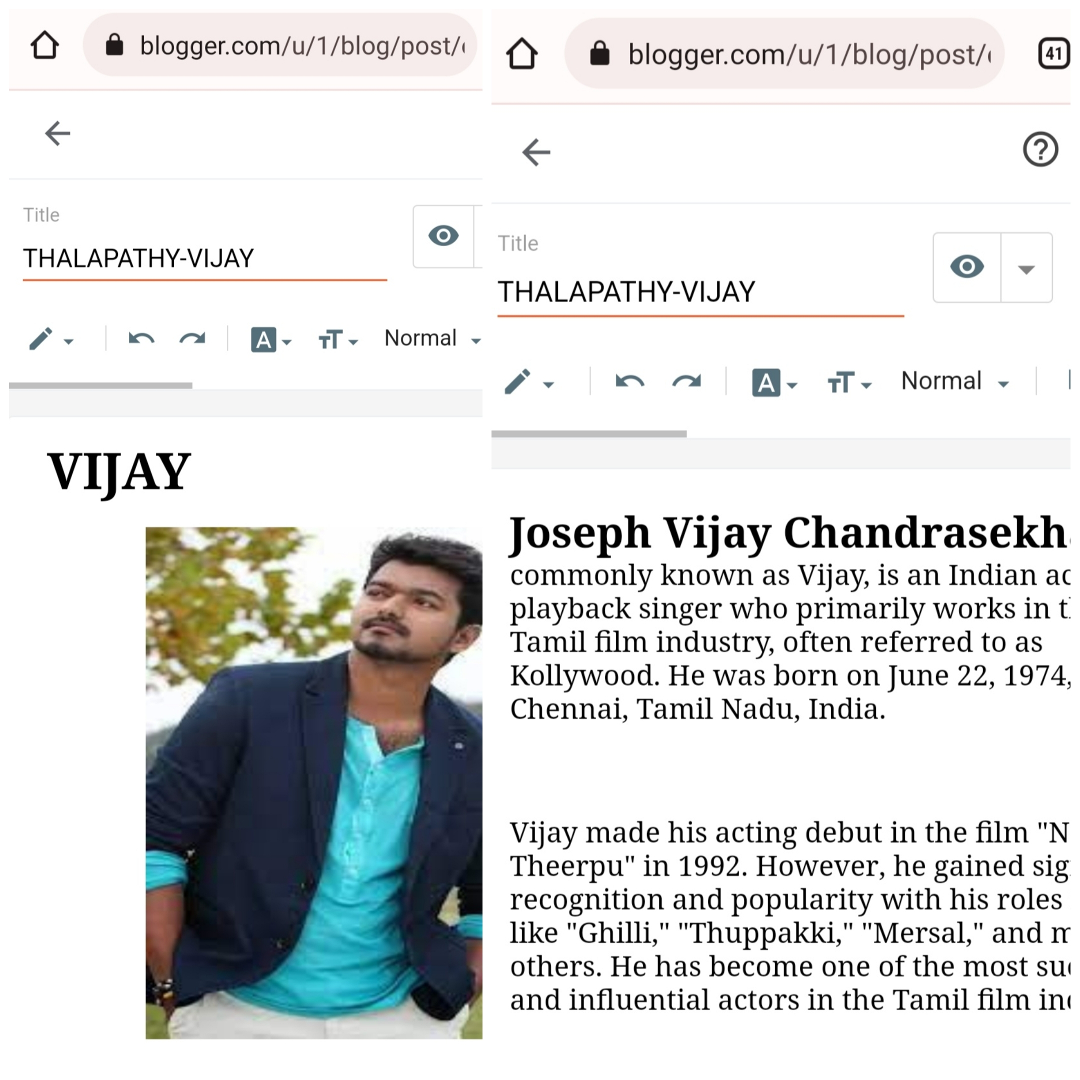ASSIGNMENT - DIGITAL MARKETING

|  |  |
| --- | --- |
| Reg No | 96282010635 |
| NAME | SUJITHA. T |
| NM ID | E81373B85B480ADAD4E40D917358A1C5 |
| Date | 22-10-2023 |

1.Create a blog or website using Blogspot and WordPress. Customize the theme design and post new article with 500 words.

Link: https://nilachandrayaan3.blogspot.com/2023/08/moon-earths-natural-satelite.html

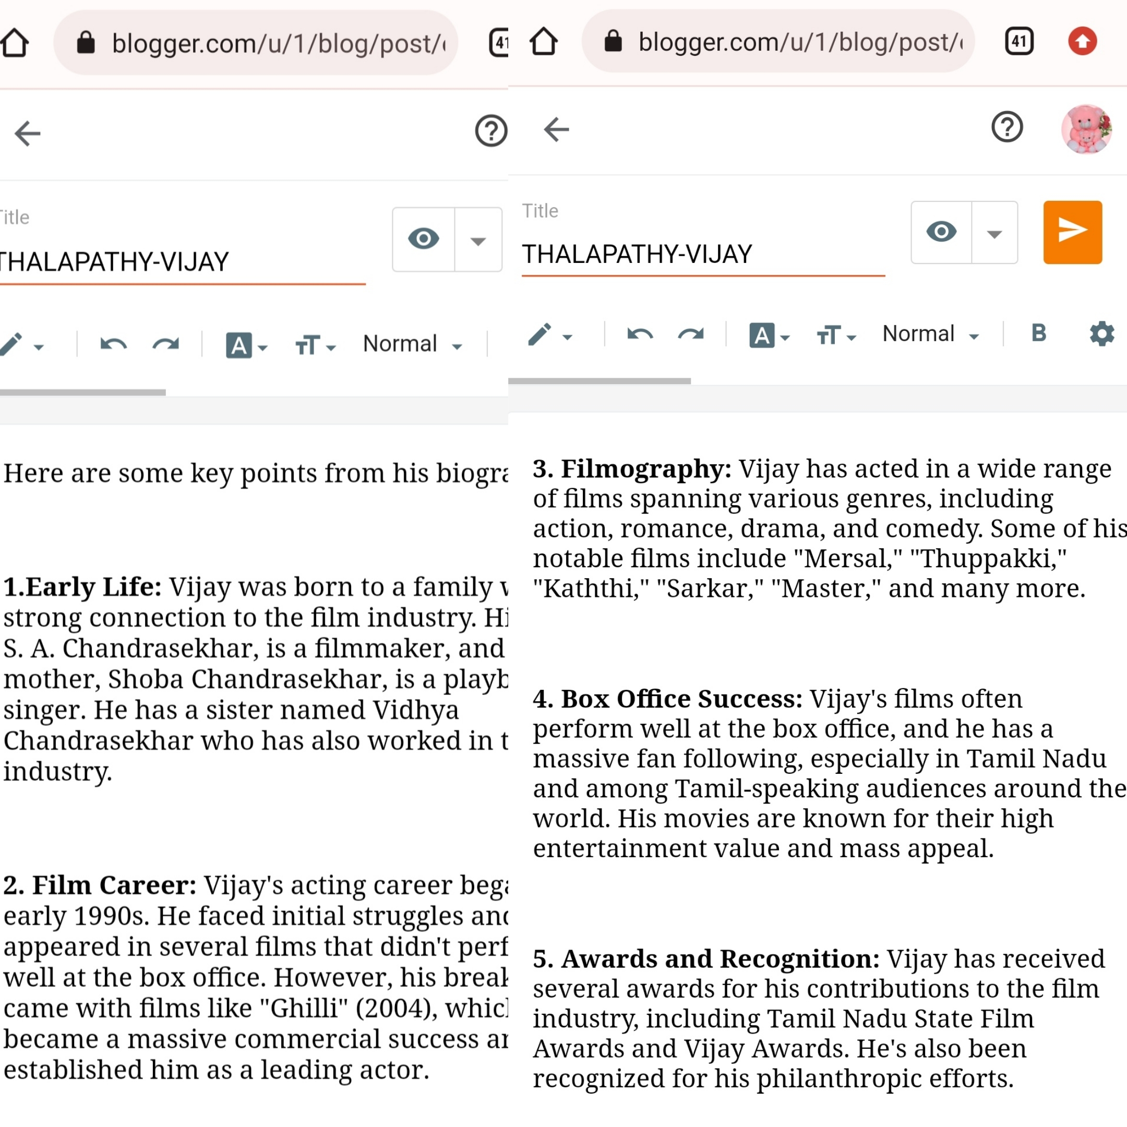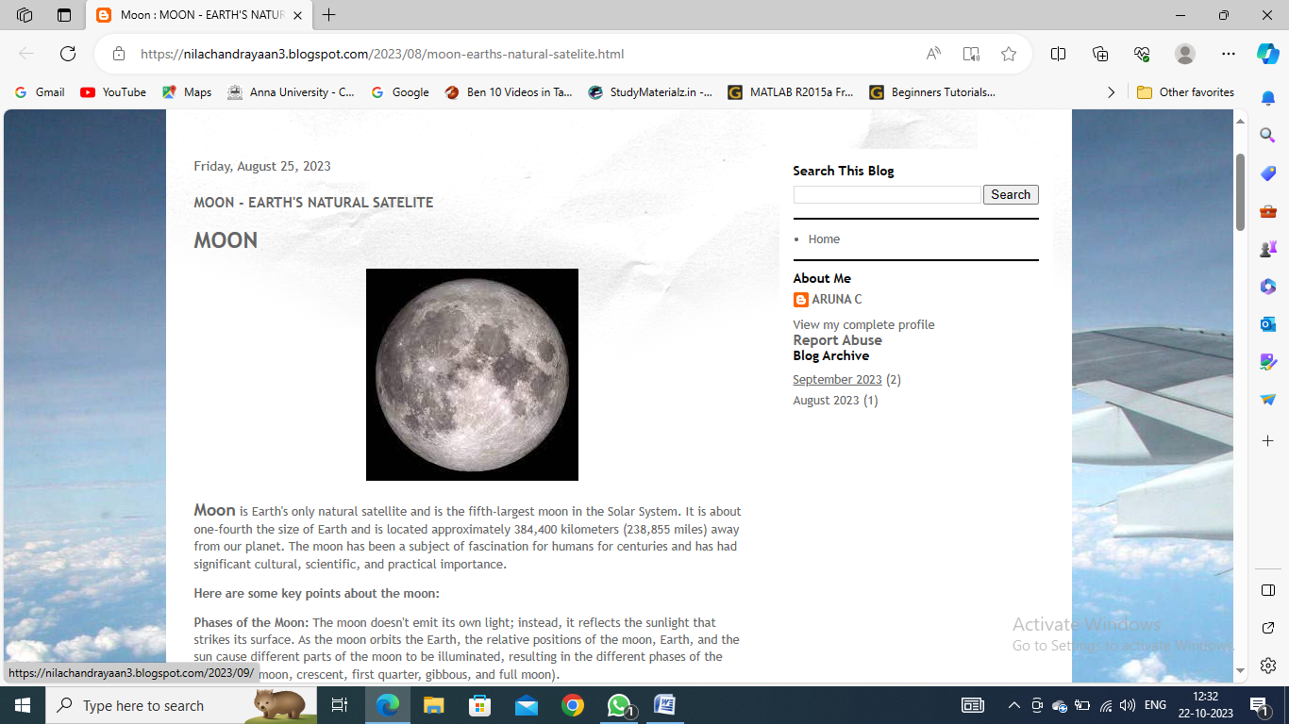

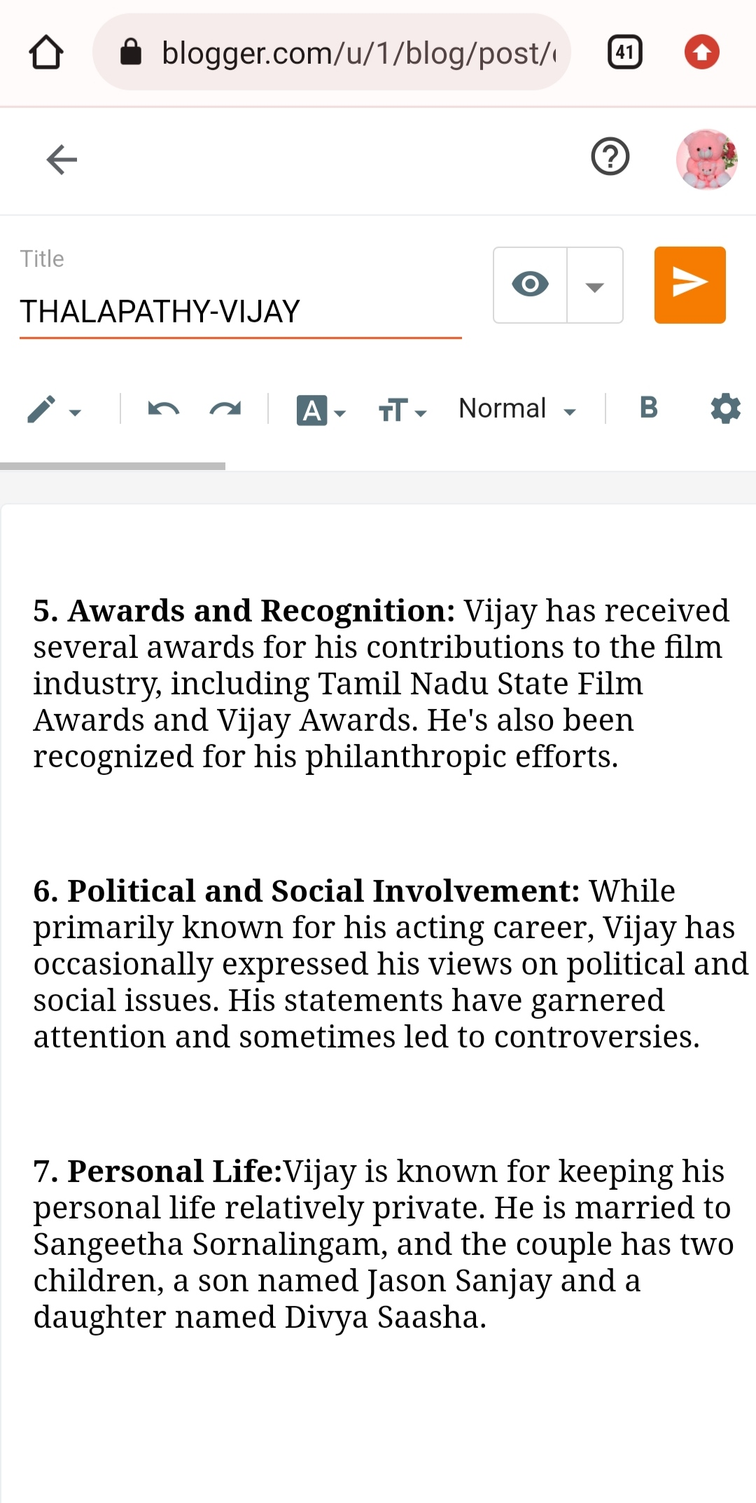

**2**.Create a new facebook page and post one social media poster for your brand.

Link : https://m.facebook.com/story.php?story_fbid=pfbid08vmC7h7fTe8hD5Kz6dSjbxn1tkYEXL2kaTjeRC1Q8GpG7eoq6mmcSfBXQ9kJ8RiBl&id=61550479203573&mibextid=Nif5oz

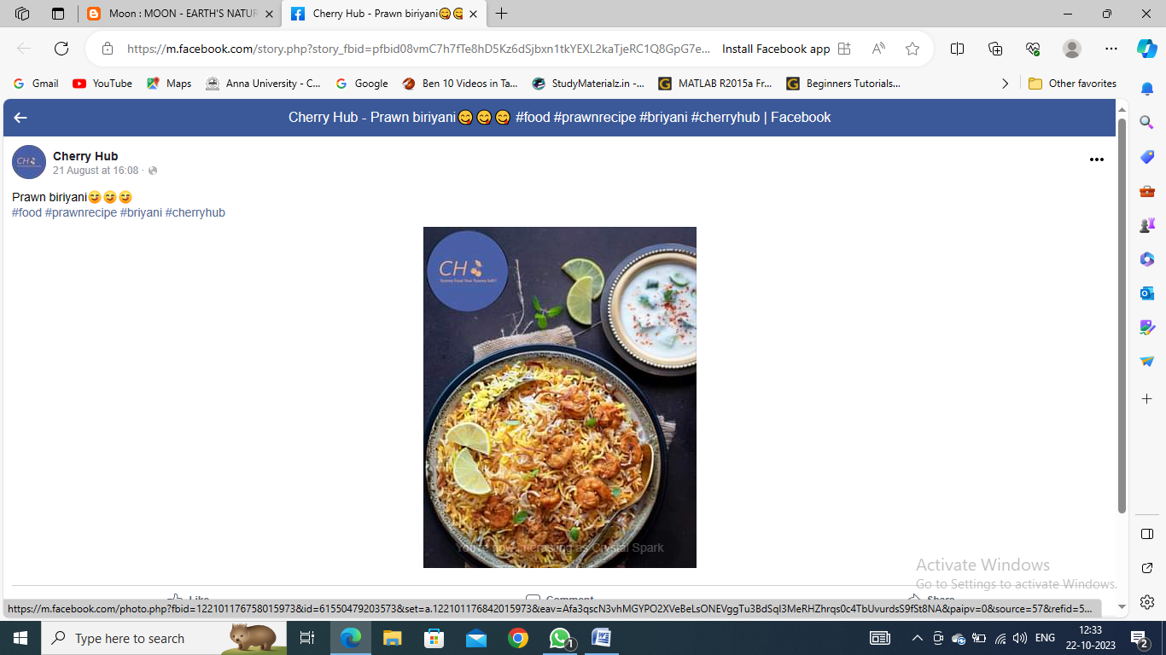

**3**.Create and design a social media advertisement poster using canva

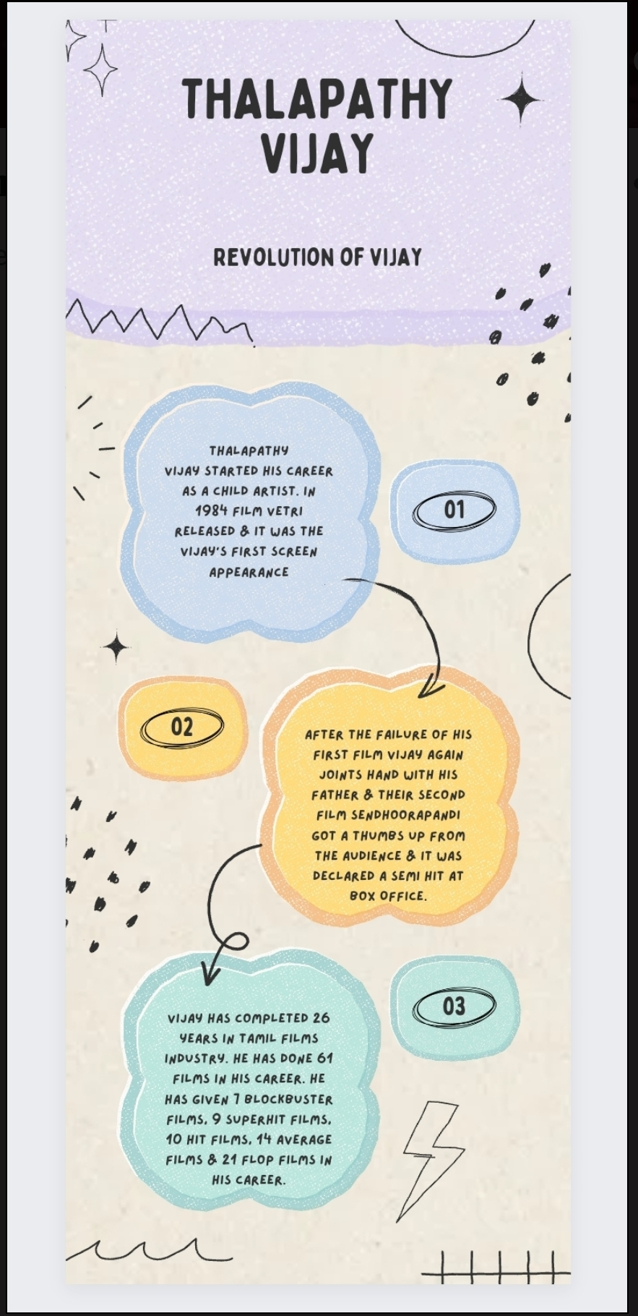

4.Create email newsletter design using MailChimp or canva tool.

Link:Using canva

https://sujithat35.blogspot.com/2023/09/vijay-email-newsletter.html

